ЛАБОРАТОРНА РОБОТА № 1
ПОПЕРЕДНЯ ОБРОБКА ТА КОНТРОЛЬОВАНА КЛАСИФІКАЦІЯ ДАНИХ
Варіант 13
Хід роботи:
Завдання 1:
Код програми:
import numpy as np
from sklearn import preprocessing

def binarize(target, threshold=2.1):
binarizer = preprocessing.Binarizer(threshold=threshold)
return binarizer.transform(target)

def print_mean_and_deviation(data):
print(f"Mean: {data.mean(axis=0)}")
print(f"Std deviation: {data.std(axis=0)}")

def scale(target):
return preprocessing.scale(target)

def min_max_scale(target):
scaler = preprocessing.MinMaxScaler(feature_range=(0, 1))
return scaler.fit_transform(target)

def normalize(target, norm="l1"):
return preprocessing.normalize(target, norm=norm)

input_data = np.array(
[
[1.3, 3.9, 6.2],
[4.9, 2.2, -4.3],
[-2.6, 6.5, 4.1],
[-5.2, -3.4, -5.2],
]
)

binarized_data = binarize(input_data, 2.0)
print(f"Binarized data:\n{binarized_data}")

print()

print("BEFORE:")
print_mean_and_deviation(input_data)
scaled_data = scale(input_data)
print("AFTER:")
print_mean_and_deviation(scaled_data)

print()

min_max_scaled_data = min_max_scale(input_data)
print(f"Min max scaled data:\n{min_max_scaled_data}")

print()

l1_normalized_data = normalize(input_data, "l1")
print(f"l1 normalized data:\n{l1_normalized_data}")

print()

l2_normalized_data = normalize(input_data, "l2")
print(f"l2 normalized data:\n{l2_normalized_data}")

Виконання програми:
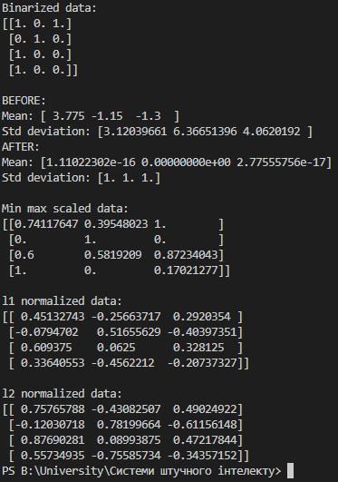
Рис 1.1 – Результат виконання програми
Висновок: діапазон значень при L1 більший, коли як у L2 він менший, що змушує всі ознаки бути однаковими.

Завдання 2:
Код програми:
from sklearn import preprocessing

def train_encoder(target):
encoder = preprocessing.LabelEncoder()
encoder.fit(target)
return encoder

def print_label_mapping(encoder):
print("Label mapping:")
for i, item in enumerate(encoder.classes_):
print(f"{item} --> {i}")

def encode_labels(encoder, labels):
return encoder.transform(labels)

def print_encoded_labels(input, output):
print(f"Labels: {input}")
print(f"Encoded values: {list(output)}")

def decode_values(encoder, values):
return encoder.inverse_transform(values)

def print_decoded_values(input, output):
print(f"Values: {input}")
print(f"Decoded labels: {list(output)}")

input_labels = ["red", "black", "red", "green", "black", "yellow", "white"]

encoder = train_encoder(input_labels)
print_label_mapping(encoder)
print()

labels = ["green", "red", "black"]
encoded_values = encode_labels(encoder, labels)
print_encoded_labels(labels, encoded_values)
print()

values = [3, 0, 4, 1]
decoded_labels = decode_values(encoder, values)
print_decoded_values(values, decoded_labels)
Виконання програми:
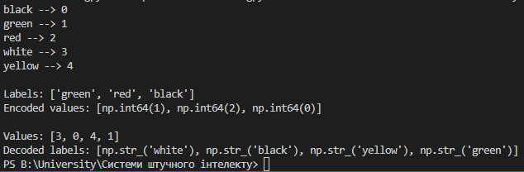
Рис. 1.2 – Результат виконання програми

Завдання 3:
Код програми:
import numpy as np
from sklearn import preprocessing

def binarize(target, threshold=2.1):
binarizer = preprocessing.Binarizer(threshold=threshold)
return binarizer.transform(target)

def print_mean_and_deviation(data):
print(f"Mean: {data.mean(axis=0)}")
print(f"Std deviation: {data.std(axis=0)}")

def scale(target):
return preprocessing.scale(target)

def min_max_scale(target):
scaler = preprocessing.MinMaxScaler(feature_range=(0, 1))
return scaler.fit_transform(target)

def normalize(target, norm="l1"):
return preprocessing.normalize(target, norm=norm)

input_data = np.array(
[
[-2.3, -1.6, -6.1],
[-2.4, -1.2, 4.3],
[3.2, 3.1, 6.1],
[-4.4, 1.4, -1.2],
]
)

binarized_data = binarize(input_data, 2.1)
print(f"Binarized data:\n{binarized_data}")

print()

print("BEFORE:")
print_mean_and_deviation(input_data)
scaled_data = scale(input_data)
print("AFTER:")
print_mean_and_deviation(scaled_data)

print()

min_max_scaled_data = min_max_scale(input_data)
print(f"Min max scaled data:\n{min_max_scaled_data}")

print()

l1_normalized_data = normalize(input_data, "l1")
print(f"l1 normalized data:\n{l1_normalized_data}")

print()

l2_normalized_data = normalize(input_data, "l2")
print(f"l2 normalized data:\n{l2_normalized_data}")

Виконання програми:
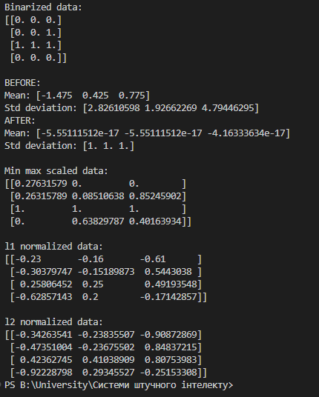
Рис. 1.3 – Результат виконання програми
Завдання 4:
Код програми:
import numpy as np
from sklearn import linear_model
from utilities import visualize_classifier

def create_classifier():
return linear_model.LogisticRegression(solver="liblinear", C=1)

def train_classifier(classifier, x, y):
classifier.fit(x, y)

x = np.array(
[
[3.1, 7.2],
[4, 6.7],
[2.9, 8],
[5.1, 4.5],
[6, 5],
[5.6, 5],
[3.3, 0.4],
[3.9, 0.9],
[2.8, 1],
[0.5, 3.4],
[1, 4],
[0.6, 4.9],
]
)
y = np.array([0, 0, 0, 1, 1, 1, 2, 2, 2, 3, 3, 3])

classifier = create_classifier()
train_classifier(classifier, x, y)
visualize_classifier(classifier, x, y)
Виконання програми:
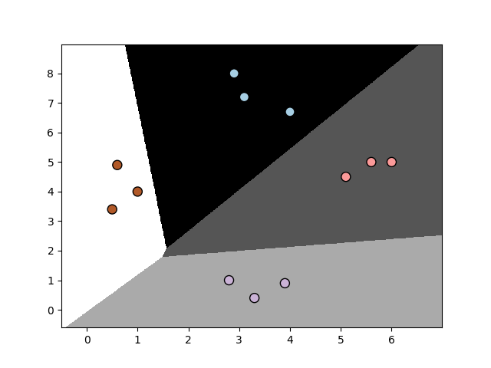
Рис. 1.4 – Результат виконання програми

Завдання 4:
Код програми:
import numpy as np
from sklearn.model_selection import train_test_split, cross_val_score
from sklearn.naive_bayes import GaussianNB

from utilities import visualize_classifier

def load_arrays(filepath):
data = np.loadtxt(filepath, delimiter=",")
x = data[:, :-1]
y = data[:, -1]
return x, y

def train_classifier(x, y):
classifier = GaussianNB()
classifier.fit(x, y)
return classifier

def get_prediction_accuracy(x, y, y_prediction):
return 100.0 * (y == y_prediction).sum() / x.shape[0]

def print_accuracy(classifier, x, y, num_folds=3):
values = cross_val_score(classifier, x, y, scoring="accuracy", cv=num_folds)
print("Accuracy: " + str(round(100 * values.mean(), 2)) + "%")

def print_precision(classifier, x, y, num_folds=3):
values = cross_val_score(
classifier, x, y, scoring="precision_weighted", cv=num_folds
)
print("Precision: " + str(round(100 * values.mean(), 2)) + "%")

def print_recall(classifier, x, y, num_folds=3):
values = cross_val_score(classifier, x, y, scoring="recall_weighted", cv=num_folds)
print("Recall: " + str(round(100 * values.mean(), 2)) + "%")

def print_f1(classifier, x, y, num_folds=3):
values = cross_val_score(classifier, x, y, scoring="f1_weighted", cv=num_folds)
print("F1: " + str(round(100 * values.mean(), 2)) + "%")

x, y = load_arrays("Лабораторна робота 1/data_multivar_nb.txt")
classifier = train_classifier(x, y)

y_prediction = classifier.predict(x)
accuracy = get_prediction_accuracy(x, y, y_prediction)
print(f"Accuracy of Naive Bayes = {round(accuracy, 2)}%")
print_accuracy(classifier, x, y)
print_precision(classifier, x, y)
print_recall(classifier, x, y)
print_f1(classifier, x, y)

x_training, x_test, y_training, y_test = train_test_split(
x, y, test_size=0.2, random_state=3
)
new_classifier = train_classifier(x_training, y_training)

y_test_prediction = new_classifier.predict(x_test)
accuracy = get_prediction_accuracy(x_test, y_test, y_test_prediction)
print(f"Accuracy of the new classifier = {round(accuracy, 2)}%")

visualize_classifier(new_classifier, x_test, y_test)

Виконання програми:
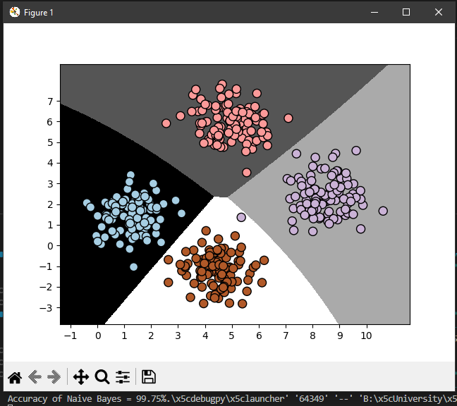
Рис. 1.5 – Результат виконання програми

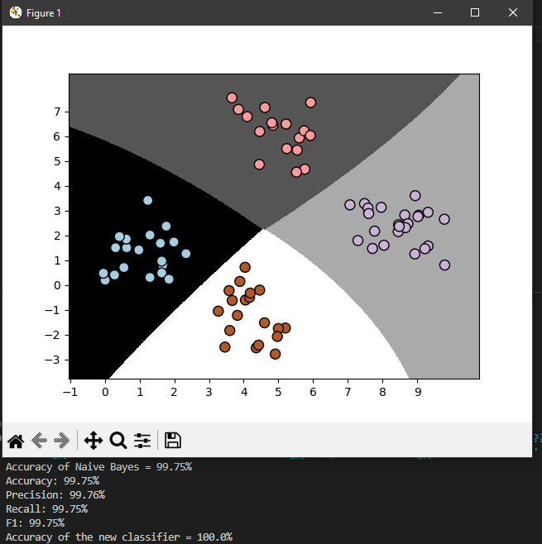
Рис. 1.6 – Перше виконання програми
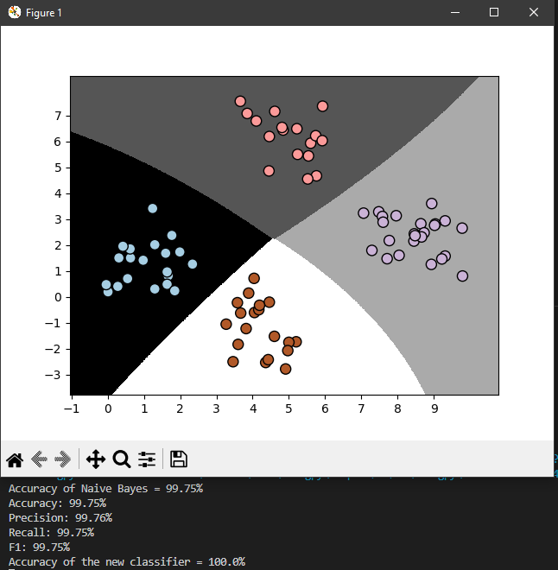
Рис. 1.7 – Друге виконання програми
Висновок: Перший та другий прогін програми нічим не відрізняються

Завдання 5:
import pandas as pd
import numpy as np
import matplotlib.pyplot as plt
from sklearn.metrics import confusion_matrix as get_confusion_matrix
from sklearn.metrics import accuracy_score as get_accuracy_score
from sklearn.metrics import recall_score as get_recall_score
from sklearn.metrics import precision_score as get_precision_score
from sklearn.metrics import f1_score as get_f1_score
from sklearn.metrics import roc_curve as get_roc_curve
from sklearn.metrics import roc_auc_score as get_roc_auc_score

def get_dataframe(filename):
dataframe = pd.read_csv(filename)

return dataframe

def binarize(y, threshold=0.5):
y_prediction = np.where(y >= threshold, 1, 0)
return y_prediction

def korniichuk_confusion_matrix(y, y_prediction):
tp = korniichuk_tp(y, y_prediction)
fn = korniichuk_fn(y, y_prediction)
fp = korniichuk_fp(y, y_prediction)
tn = korniichuk_tn(y, y_prediction)
return np.array([[tn, fp], [fn, tp]])

def korniichuk_tp(y, y_prediction):
result = 0
for actual, predicted in zip(y, y_prediction):
if actual == 1 and predicted == 1:
result += 1
return result

def korniichuk_fn(y, y_prediction):
result = 0
for actual, predicted in zip(y, y_prediction):
if actual == 1 and predicted == 0:
result += 1
return result

def korniichuk_fp(y, y_prediction):
result = 0
for actual, predicted in zip(y, y_prediction):
if actual == 0 and predicted == 1:
result += 1
return result

def korniichuk_tn(y, y_prediction):
result = 0
for actual, predicted in zip(y, y_prediction):
if actual == 0 and predicted == 0:
result += 1
return result

def split_confusion_matrix(matrix):
tn = matrix[0][0]
fp = matrix[0][1]
fn = matrix[1][0]
tp = matrix[1][1]
return tp, fn, fp, tn

def print_confusion_matrix(matrix):
tp, fn, fp, tn = split_confusion_matrix(matrix)
print(f"TP: {tp}")
print(f"FN: {fn}")
print(f"FP: {fp}")
print(f"TN: {tn}")

def korniichuk_accuracy_score(confusion_matrix):
tp, fn, fp, tn = split_confusion_matrix(confusion_matrix)
return (tp + tn) / (tp + tn + fp + fn)

def korniichuk_recall_score(confusion_matrix):
tp, fn, _, _ = split_confusion_matrix(confusion_matrix)
return tp / (tp + fn)

def korniichuk_precision_score(confusion_matrix):
tp, _, fp, _ = split_confusion_matrix(confusion_matrix)
return tp / (tp + fp)

def korniichuk_f1_score(confusion_matrix):
recall_score = korniichuk_recall_score(confusion_matrix)
precision_score = korniichuk_precision_score(confusion_matrix)
return (2 * (precision_score * recall_score)) / (precision_score + recall_score)

def build_roc_plot(fpr_y1, tpr_y1, fpr_y2, tpr_y2):
plt.plot(fpr_y1, tpr_y1, "r-", label="RF")
plt.plot(fpr_y2, tpr_y2, "b-", label="LR")
plt.plot([0, 1], [0, 1], "k-", label="random")
plt.plot([0, 0, 1, 1], [0, 1, 1, 1], "g-", label="perfect")
plt.legend()
plt.xlabel("False Positive Rate")
plt.ylabel("True Positive Rate")
plt.show()

dataframe = get_dataframe("Лабораторна робота 1/data_metrics.csv")

y, y1_prediction, y2_prediction = (
dataframe.actual_label.array,
dataframe.model_RF.array,
dataframe.model_LR.array,
)
y1_prediction = binarize(y1_prediction)

# CONFUSION_MATRIX
my_confusion_matrix = korniichuk_confusion_matrix(
y,
y1_prediction,
)
confusion_matrix = get_confusion_matrix(y, y1_prediction)

print("Korniichuk Confusion matrix:")
print_confusion_matrix(my_confusion_matrix)

print("\nSKLearn Confusion matrix:")
print_confusion_matrix(confusion_matrix)

assert np.array_equal(confusion_matrix, my_confusion_matrix)

# ACCURACY_SCORE
my_accuracy_score = korniichuk_accuracy_score(confusion_matrix)
print(f"\nKorniichuk accuracy score = {my_accuracy_score}")

accuracy_score = get_accuracy_score(y, y1_prediction)
print(f"SKLearn accuracy score = {accuracy_score}")

assert my_accuracy_score == accuracy_score

# RECALL_SCORE
my_recall_score = korniichuk_recall_score(confusion_matrix)
print(f"\nKorniichuk recall score = {my_recall_score}")

recall_score = get_recall_score(y, y1_prediction)
print(f"SKLearn recall score = {recall_score}")

assert my_recall_score == recall_score

# PRECISION_SCORE
my_precision_score = korniichuk_precision_score(confusion_matrix)
print(f"\nKorniichuk precision score = {my_precision_score}")

precision_score = get_precision_score(y, y1_prediction)
print(f"SKLearn precision score = {precision_score}")

assert my_precision_score == precision_score

# F1_SCORE
my_f1_score = korniichuk_f1_score(confusion_matrix)
print(f"\nKorniichuk f1 score = {my_f1_score}")

f1_score = get_f1_score(y, y1_prediction)
print(f"SKLearn f1 score = {f1_score}")

assert my_f1_score == f1_score

# ROC_CURVE
fpr_y1, tpr_y1, thresholds_y1 = get_roc_curve(y, y1_prediction)
fpr_y2, tpr_y2, thresholds_y2 = get_roc_curve(y, y2_prediction)
build_roc_plot(fpr_y1, tpr_y1, fpr_y2, tpr_y2)

# ROC_AUC_SCORE
roc_auc_score1 = get_roc_auc_score(y, y1_prediction)
print(f"\nAUC 1 = {roc_auc_score1}")
roc_auc_score2 = get_roc_auc_score(y, y2_prediction)
print(f"AUC 2 = {roc_auc_score2}")

Виконання програми:
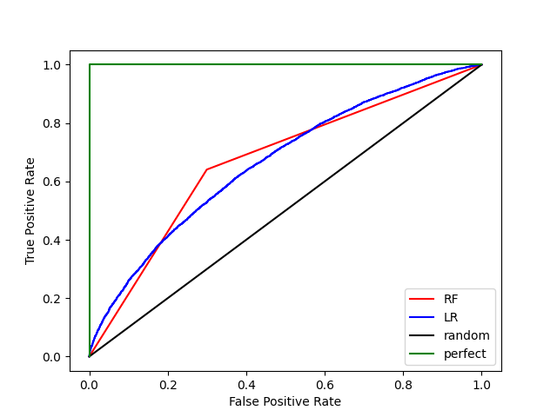
Рис. 1.8 – Виконання програми
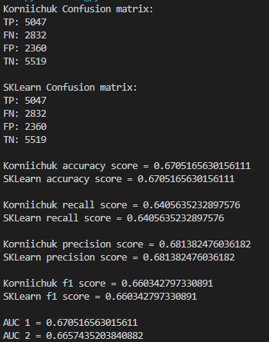
Рис. 1.9 – Виконання програми
Висновки: RF модель є кращою, тому що її roc auc вище

Завдання 6:
Код програми:
import numpy as np
from sklearn.model_selection import train_test_split, cross_val_score
from sklearn.svm import SVC
from sklearn.naive_bayes import GaussianNB
from sklearn.metrics import confusion_matrix as get_confusion_matrix

def load_arrays(filepath):
data = np.loadtxt(filepath, delimiter=",")
x = data[:, :-1]
y = data[:, -1]
return x, y

def create_svm(x, y):
svm = SVC()
svm.fit(x, y)
return svm

def create_naive(x, y):
naive = GaussianNB()
naive.fit(x, y)
return naive

def predict(classifier, x):
return classifier.predict(x)

def evaluate_model(classifier, x, y, num_folds=3):
accuracy = cross_val_score(
classifier, x, y, cv=num_folds, scoring="accuracy"
).mean()
precision = cross_val_score(
classifier, x, y, cv=num_folds, scoring="precision_macro"
).mean()

recall = cross_val_score(
classifier, x, y, cv=num_folds, scoring="recall_macro"
).mean()
f1 = cross_val_score(classifier, x, y, cv=num_folds, scoring="f1_macro").mean()

print(f"Accuracy = {accuracy}")
print(f"Precision = {precision}")
print(f"Recall = {recall}")
print(f"F1-score = {f1}")

y_prediction = classifier.predict(x)
confusion_matrix = get_confusion_matrix(y, y_prediction)
print("Confusion Matrix:\n", confusion_matrix)

x, y = load_arrays("Лабораторна робота 1/data_multivar_nb.txt")
x_train, x_test, y_train, y_test = train_test_split(x, y, test_size=0.2, random_state=3)

svm = create_svm(x_train, y_train)
naive = create_naive(x_train, y_train)

svm_prediction = predict(svm, x_test)
naive_prediction = predict(naive, x_test)

print("SVM:")
evaluate_model(svm, x_test, y_test)

print("\nNaive Bayes:")
evaluate_model(naive, x_test, y_test)

Виконання програми:
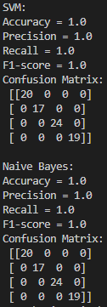
Рис. 1.10 – Виконання програми

Посилання на GitHub: https://github.com/ipz215kvv/artificial-inteligence-systems

